Communications Toolkit
for Schools

Starting Reception is an exciting milestone for children and their families. With National Offer Day taking place in April, many parents begin thinking about the transition to school and how best to support their child for this important next step.
This document is designed to help schools promote Starting Reception to prospective parents so that children are ready to start school in the best way possible. The messaging in this toolkit is particularly relevant to parents whose children will be starting Reception in September 2026. If children aren’t yet potty trained, the document provides relevant links to the Potty Training Guide to support families with this. There is also additional support around oral health.
In the document, you can find the links to the relevant digital PDFs, printable PDFs and editable copy that can be used and adapted for your relevant comms channels.
Links to the Guides
- Starting Reception
  - Visit the Starting Reception website
  - Find a QR code, editable email copy, website copy and social media assets
  - Download the Starting Reception Definition as a PDF
- The Potty Training Guide
  - Visit the Potty Training Guide website
  - Find a QR code, editable email copy and website copy
  - Download the Potty Training Guide as a PDF
- The Children’s Toothbrushing Guide
  - Visit the Children's Toothbrushing Guide website
  - QR Code
  - Download the Children's Toothbrushing Guide as a PDF

Starting Reception
The Starting Reception definition, was created by the early years sector. It’s a definition of the skills children need when starting Reception. It is welcomed by Government and sign posted from the Best Start in Life website.
Read the definition online (www.startingreception.co.uk).
The PDF of the definition can also be downloaded here.
Starting Reception Links - QR code/URL link
Use the QR code below to direct people straight to the Starting Reception definition.
Alternatively, visit: https://startingreception.co.uk/
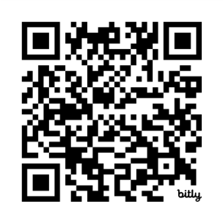

Editable email copy
Use the editable copy to encourage parents to visit Starting Reception and to look at the definition. In this section, see:
- Email copy
- Website copy
- Social Media Assets - caption copy and image templates

Email copy #1 | On National Offer Day
For your school to share with parents of children starting in September:
Starting school is an exciting milestone for your child and your family. To help make the transition into Reception as smooth and positive as possible, we encourage you to explore Starting Reception (www.startingreception.co.uk), where you’ll find practical tips, activities and guidance to help your child feel confident on their first day. Supporting your child now can make a big difference in helping them thrive in September.

Email copy #2 | During the summer holidays
For your school to share with parents a gentle reminder.
There are only a few weeks to go until your child joins us in September and we’re very much looking forward to welcoming them.
To help you prepare over the coming months, we encourage you to take a look at the Starting Reception guide. This guide is widely used across the sector and highlights some of the key skills and experiences that children often benefit from practising before they begin school. Every child develops at their own pace, but becoming familiar with these skills can help your child feel more confident and settled as they start their Reception journey.

Website copy
Copy for your website:
Starting Reception is an exciting milestone for your child and your family. So that they can thrive from the very first day, we encourage you to take a look at Starting Reception to find a list of skills you and your child can practice at home before September.

Social Media Assets – caption copy and images
We’ve created a set of editable, royalty-free social media images for use in promoting the Starting Reception Definition via your own channels. The document also provides tips on how to use these images as well as ready-to-use caption copy.
Download here.

The Potty Training Guide
We know that, nationally, 1 in 4 children start Reception not fully toilet trained. This places a huge burden on Reception staff. The Potty Training Guide, created by the early years sector and welcomed by Government, offer families evidence-based advice on how and when to potty train.
  - Digital
  - Download PDF Guide

Potty Training links – QR Code/URL Link:
Use the QR code below to direct people straight to the Potty Training Guide.
Alternatively, visit: www.pottytrainingguide.co.uk

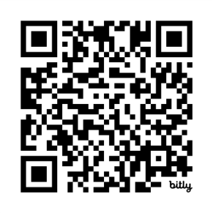

Editable email copy
As your child prepares to start Reception, we encourage families to continue supporting them in developing independence with toileting, as this is one of the skills that helps children feel confident and settled in school (unless there is a diagnosed medical condition, such as a bowel or bladder condition). You may find our Potty Training Guide helpful, which has been developed in line with guidance from early years experts, and of course please do get in touch if you would like to discuss your child’s individual needs.
Website copy
We encourage families to work towards their child being toilet trained ahead of starting school in September 2026, as this can help them feel confident and comfortable in their new environment. You may find our Potty Training Guide helpful, as it offers practical tips and advice to support your child in becoming school ready.

The Children’s Toothbrushing Guide
The Children's Toothbrushing Guide is designed to support nurseries, schools and early years professionals to share clear, trusted advice with families. Created by the early years sector, including the British Society of Paediatric Dentistry and the Oral Health Foundation, the Guide helps settings support children’s oral health from the earliest years.
- The Children’s Toothbrushing Guide
  - Digital
  - PDF Guide
The Children's Toothbrushing Guide Links – QR Code/URL Link
Use the QR code below to direct people straight to the Children’s Toothbrushing Guide.
Alternatively, visit: www.toothbrushingguide.co.uk

